Report on a two days workshop on “Artificial Intelligence and Machine Learning”

Date: 11th and 12th August 2025 Venue: E & TC Seminar Hall

Department of Electronics and Telecommunication Engineering in collaboration with IEEE SB has
organized a two days workshop on “Artificial Intelligence and Machine Learning” by Dr. Ranjeet Kumar Pathak,
Assistant Professor of GES’s R.H. Sapat College of Engineering, Management Studies and Research, Nashik.

“To empower students by fostering academic progress, personal values and professional knowledge.”
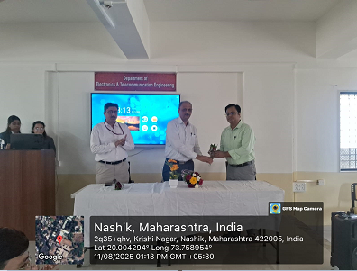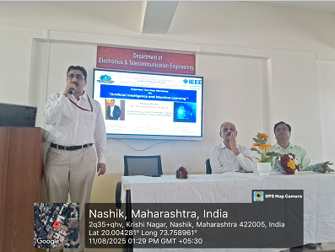

Snapshot of felicitation of Guest of Honor by Principal HOD sharing his views
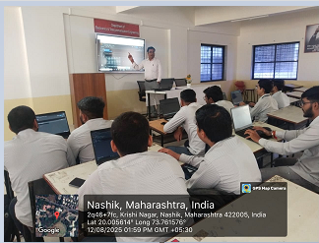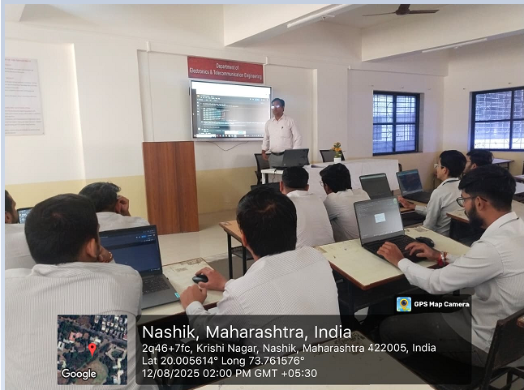
Expert while sharing his expertise End of the Session by giving vote of thanks

Event Coordinator Prof. Dr. S. P. Agnihotri
Dr. Ranjeet Kumar Pathak HOD E & TC

