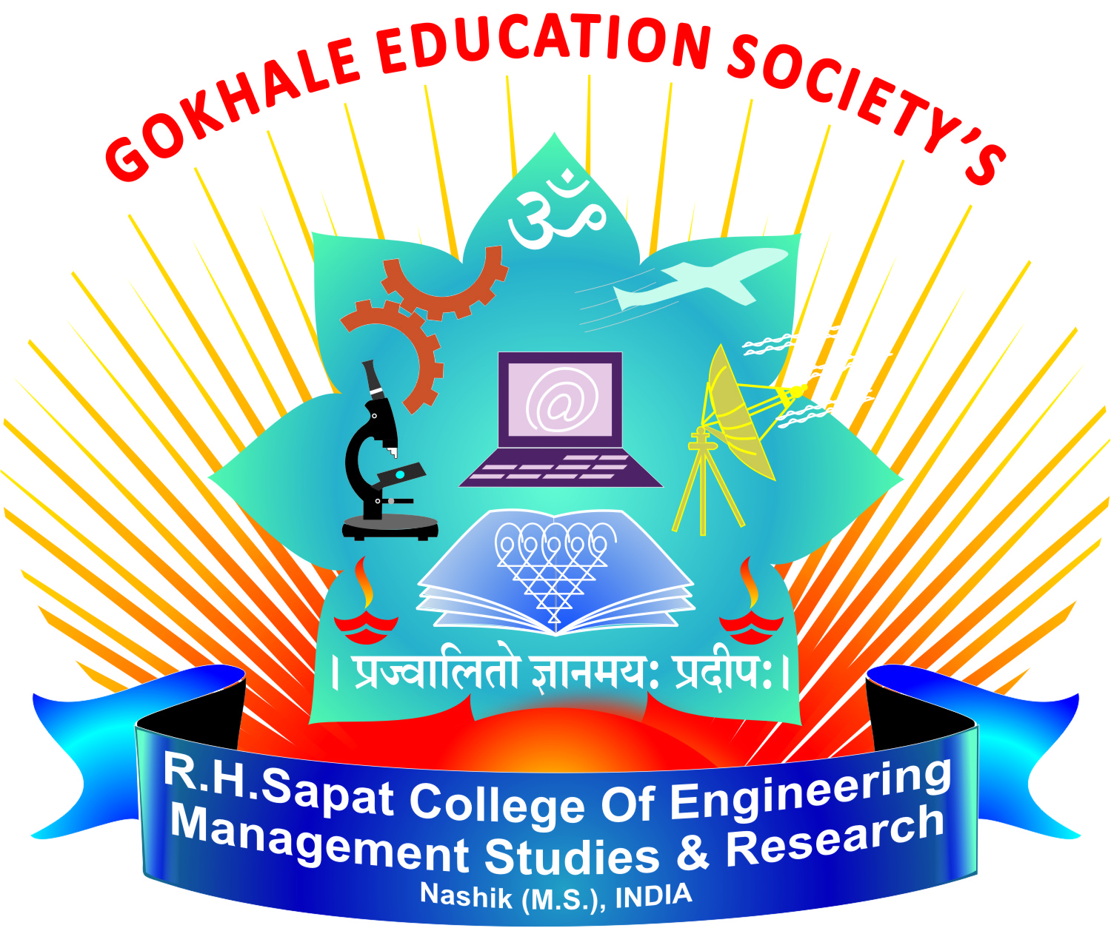
Gokhale Education Society’s
R. H. Sapat College of Engineering,
Management Studies and Research, Nashik
Department of Electronics and Telecommunication Engineering

Mock Interviews for Bosch Placement Drive
Date: 25 NOV 2025
Venue: E&TC Department’s Seminar Hall
Interview Preparation through mock interview from Industry Experts; for shortlisted students of E&TC, Electrical & Mechanical Departments.
Resource Person:
- Mr. Pradeep Deshpande, Director GIlbert & Maxwell
- Mr. Shekhar Borse, Director Borse Automations
