Report on Expert Talk on “Design and Development of Microstrip Patch Antennas & Microstrip Filters”

Date:13thAugust 2025
Venue : E & TC Seminar Hall

Department of Electronics and Telecommunication Engineering in collaboration with IEEE SB has
organized Expert Talk on “Design and Development of Microstrip Patch Antennas & Microstrip Filters” by
Dr. Jayant G. Joshi,SR. IEEE Member, Sr. Lect.(Selection Grade) GP Nashik.

“To empower students by fostering academic progress, personal values and professional knowledge.”

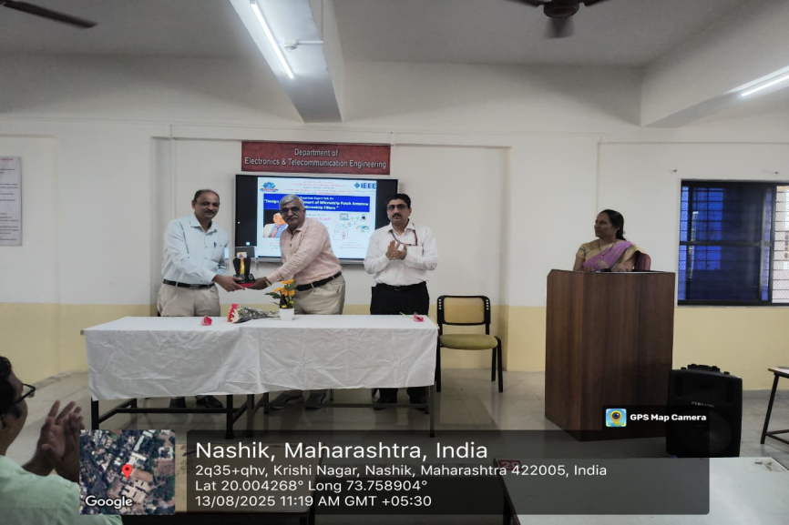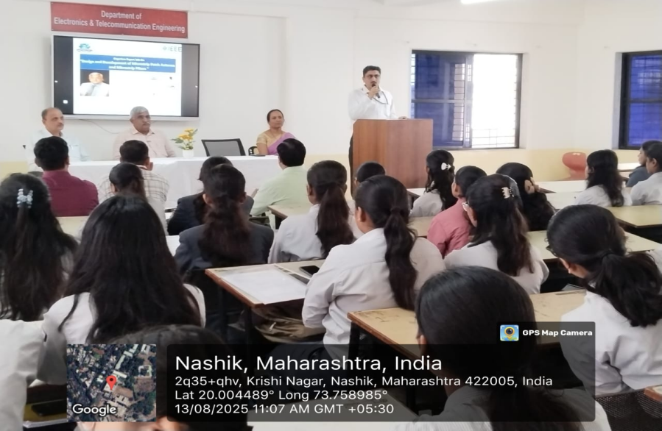
Snapshot of felicitation of Guest of Honor by Principal HOD sharing his Views

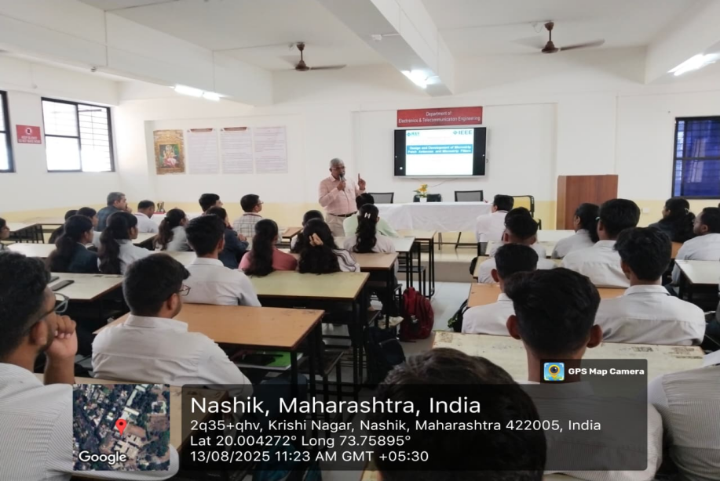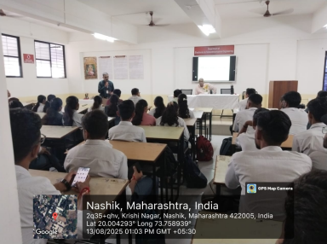
Expert while sharing his expertise End of the Session by giving vote of thanks

Mrs. M.S.Gahiwad Prof. Dr. S. P. Agnihotri
IEEE SB Counselor HOD E & TC

